**AYESHA FAISAL**

**Design Portfolio**

* **Profile Dashboard:**

A central hub to track your tasks, progress, and active projects at a glance.

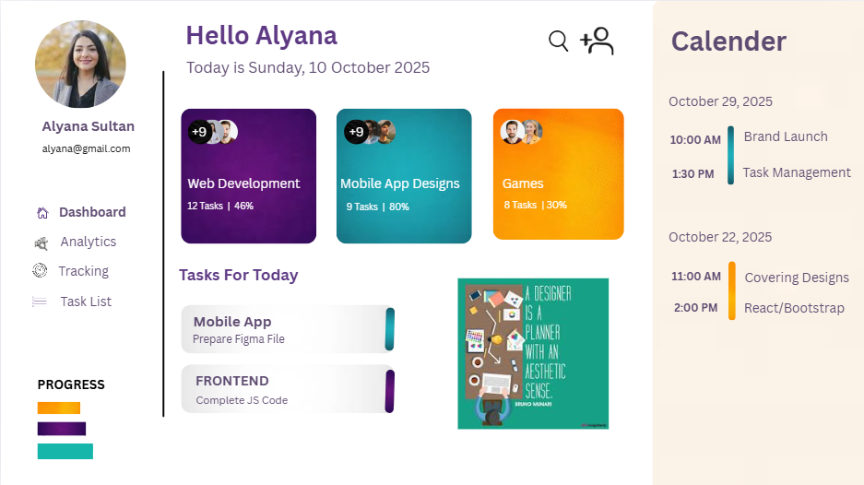

* **Educational Landing Page:**

 A welcoming gateway to discover courses and begin your learning journey.



* **Restaurant Ad:**

A visual appetizer designed to evoke craving and draw you in for a meal.

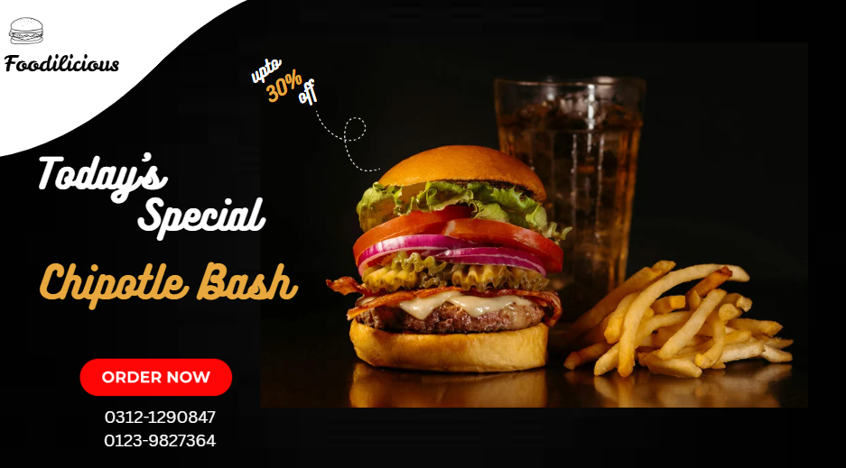

* **Event Mood Board:**

A curated collection of visuals that defines the atmosphere and tone of the event.

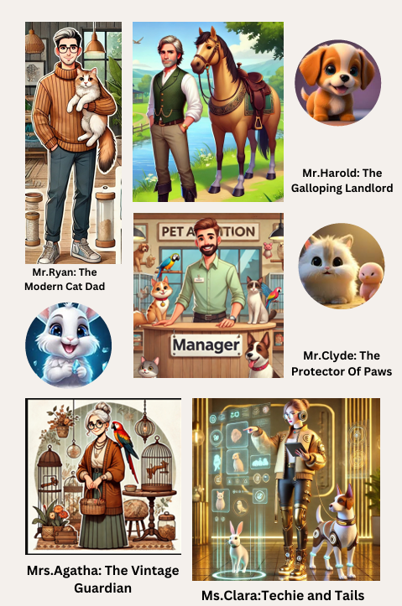

**PROCOM’26**

At **PROCOM’26**, we organized a UI/UX design competition centered around the theme **“Multiverse.”** Participants were challenged to design innovative solutions for fictional clients that we created as part of the concept. To spark creativity, we designed unique client cards representing different characters and scenarios from parallel universes—here are some of them.

